*Improve Samples and Documentation for SDR representation*

Md Tanzeem Hasan Mahmud [mahmud.mdtanzeemhasan@stud.fra-uas.de](mailto:mahmud.mdtanzeemhasan@stud.fra-uas.de)

Khan Mushfiqur Rahman  
[khan.rahman@stud.fra-uas.de](mailto:khan.rahman@stud.fra-uas.de)

*Abstract*—*This paper presents a method for visualizing Sparse Distributed Representations (SDRs) as bitmap images, leveraging the DrawBitmap utility within Hierarchical Temporal Memory (HTM) systems. SDRs, akin to the brain's data processing technique, offer a robust and efficient way to handle diverse information types. By converting SDRs into bitmap images, we can visually interpret the encoded patterns and assess the functionality of encoders and spatial pooling processes in HTM models. This approach facilitates a deeper understanding of HTM's capabilities in pattern recognition and data encoding.*

Keywords—HTM, SDR, Bitmap, DrawBitMap

# IntroDuction

Sparse Distributed Representations (SDRs) [1] are pivotal in computational models that mimic the human brain's processing, such as Hierarchical Temporal Memory (HTM) [2]. Representing data in a sparse and distributed manner allows for efficient and robust information processing. However, understanding and interpreting the complex patterns encoded within SDRs can be challenging. This paper introduces a visualization method that transforms SDRs into bitmap images, providing an intuitive way to analyze and comprehend the information encoded by HTM systems. Through the customization of DrawBitMap [3] methods parameters such as dimensions, colors, and additional text, this approach allows users to personalize visualizations to suit their unique analysis requirements, promoting a more profound comprehension of SDR properties and behaviors. This paper demonstrates the practicality and flexibility of bitmap representations in understanding the complexities of SDRs, using examples from Date Time, Scalar, and Geospatial Encoders, Binary Encoders, Spatial Pooler etc.

# Methods

In this section, we will describe the approach we followed to improve samples and documentation for SDR representation. Our objective was to visualize Sparse Distributed Representations (SDRs) as bitmap images, leveraging the DrawBitmap utility within Hierarchical Temporal Memory (HTM) systems. To achieve this, we performed DrawBitmap method. The DrawBitmap method transforms a two-dimensional array representing an SDR into a visual bitmap image. By specifying the dimensions, colours, and additional text, users can customize the visualization to suit their analysis needs. The method scales the SDR array to fit the specified bitmap dimensions, allowing for a clear and adjustable representation of the SDR's structure.

Turning an SDR into a visual bitmap involves a few straightforward steps:

1. *Setting the Scene:*

* Determine the width and height for the bitmap, scaling the image to fit your needs.
* Choose colors for the active and inactive cells to make the SDR's structure clear.

1. *Calculating the Scale*:

* A scale factor is calculated based on the ratio of the bitmap's width to the SDR array's width. This helps adjust the cell sizes in the bitmap to fit the entire SDR.

1. *Drawing the Bitmap*:

* Go through each cell in the SDR:
* Color it with the active cell color if it's active (1).
* Use the inactive cell color if it's inactive (0).
* The scale factor ensures each cell in the bitmap represents the SDR accurately.

1. *Saving the drawn bitmaps:*

* Once every cell is colored, the bitmap is saved to the location specified in file Path.
* This method simplifies analyzing and understanding SDR patterns by providing a visual representation.

Our methodology encompasses several scenarios, including basic SDR examples, encoder generated SDRs, and SDRs resulting from spatial pooling processes. We discuss the settings and configurations for various encoders, such as Scalar and Geospatial Encoders, and how they contribute to generating meaningful SDRs for visualization.

Here, we are presenting some examples that will help to understand how it works,

1. *Basic SDR Examples with binary encoders*

* Example of visualizing a number: This simple example will help to understand the visualization process, taking a simple value like 40148. Now, we must encode this data to visualize with the help of SDR. Here is the full example [4].

Then, we can get the below image from the DrawBitMap method,



Fig 1: Example of visualizing a number 40148

* Another example of visualizing a number: For this example, we will take a random integer value 50149. We will encode the value by setting up the SDR encoder settings and encode the value with those settings. and set up the two-dimensional array. Here is the full example [5].

It returns the below image,



Fig 2: Example of visualizing an integer number 50149

1. *DrawBitMap example with Binary Encoder 1D image*

We can also use DrawBitMap method for generating 1D images by getting the binary encoded value from our input. Here is the full example [6] and The Draw1DBitMap method can be found [7].



Fig 3: Example of DrawBitMap with Binary Encoder 1D image

1. *DrawBitmap example for DateTime Encoder*

A DateTime encoder is a type of encoder that transforms datetime information such as dates and times into Sparse Distributed Representations (SDRs) We can make and use different types of encoders to visualize that particular type of data in order to visualize them. We can take datetime data and encode them with DateTime encoder and visualize them with DrawBitMaps method. For this example, we can take "08/03/2024 21:58:07" and send it through datetime encoder to get SDR. The full example can be found [8].

The generated image is this,



Fig 4: DrawBitmap example for DateTime Encoder

1. *Drawing AQI Values with Scalar Encoder*

The Scalar Encoder converts AQI levels into SDRs, capturing the essence of air quality in a binary format. For instance, the AQI levels are segmented into: 0-49: Good 50-149: Moderate 150-249: Unhealthy for Sensitive Groups 250-349: Unhealthy 350-449: Very Unhealthy 450-500: Hazardous Generating Bitmaps To visualize the encoded AQI values. The full example can be found here [9].

The generated bitmap are as follows:

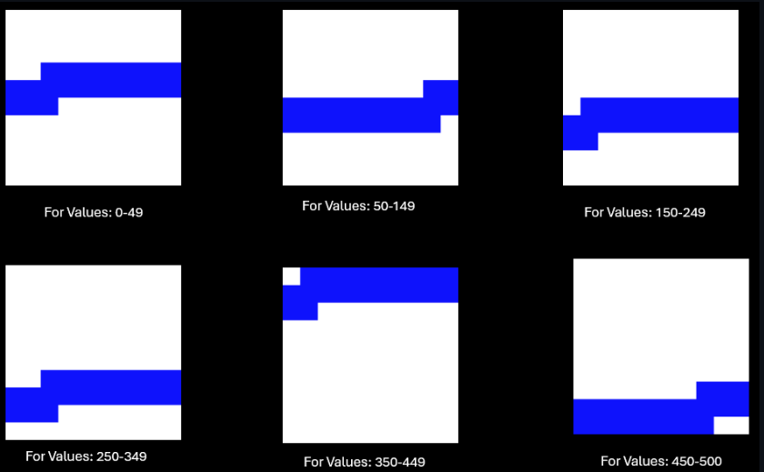

Fig 5: Drawing AQI Values with Scalar Encoder

1. *DrawBitmap sample for Geospatial Encoder*

Geospatial encoder is used to encode latitude or longitude values into Sparse Distributed Representations (SDRs) for Hierarchical Temporal Memory (HTM) systems. In the exploration of geospatial data through Sparse Distributed Representations (SDRs), we utilize the DrawBitmap method to translate encoded geographical coordinates into visually interpretable bitmap images. This approach allows for the visualization of spatial information encoded within SDRs, offering insights into the encoded geographical regions. The full example can be found here [10].

The generated bitmap are as follows:



Fig 6: *DrawBitmap sample for Geospatial Encoder*

The bitmap images generated for geographical coordinates offer a unique view of the spatial patterns encoded within the SDRs. Now if we change the encoder settings and provide the below settings: The bitmap images generated for geographical coordinates offer a unique view of the spatial patterns encoded within the SDRs. Now if we change the encoder settings and provide the below settings:



The output will be different for the same value. The bitmaps generated in this case are:



Fig 7: DrawBitmap sample for Geospatial Encoder after encoder changed.

1. *Bitmap representation of Image using Spatial Pooler*

In the context of Hierarchical Temporal Memory (HTM) theory, the Spatial Pooler (SP) plays a crucial role in transforming input data into Sparse Distributed Representations (SDRs). These representations capture the essential features of the input data in a way that emphasizes structural and semantic similarities. To visually understand the transformation process and the output of the Spatial Pooler, we can represent SDRs as bitmaps. This example elaborates on how active arrays generated by the SpatialPooler are converted into bitmap images, further enhancing our understanding of HTM's processing capabilities. The full example can be found here [11].

The DrawBitmaps utility function generates bitmap images that visually represent the active columns as a result of the SP's processing. The generated Images looks like this.



Fig 8:

On the right side we can see the images generated from the binarized file of the input training image, on the left we have the SDR representation by SpatialPooler after feeding the training image.

Example representing Overlap (Intersection), Difference and Union for Alphabet T and Numeric 3 in Bitmap after computing in spatial pooler:

Here we can see the Alphabet T and Numeric 3

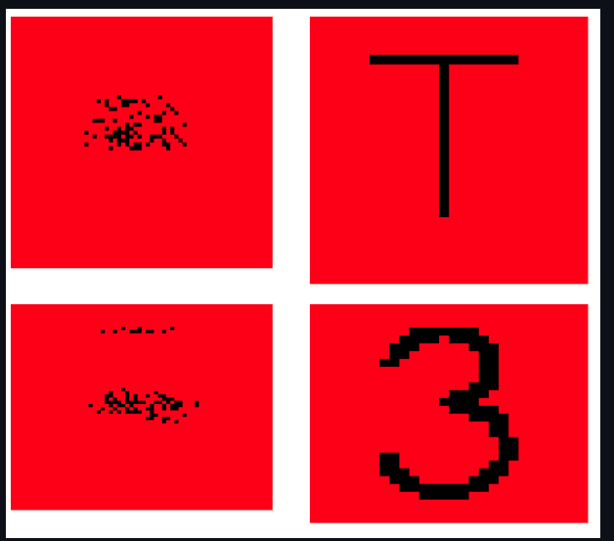

Fig 9:

Below is the representation for Overlap, Difference and Union:

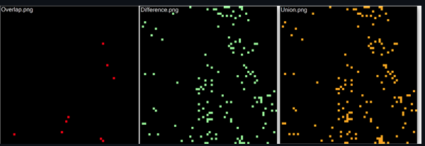

Fig 10:

Two SDRs are compared with the help of UnionSDRFun(), DiffSDRFun() and OverlapSDRFun() functions. The overlap.png shows very few intersections as the SDRs are very different from each other. Basically, the combination of Overlap and Difference gives us Union.

Example representing Overlap (Intersection), Difference and Union for Alphabet T and 1 in Bitmap after computing in spatial pooler.

Generated Bitmap representation of T and l is shown below:

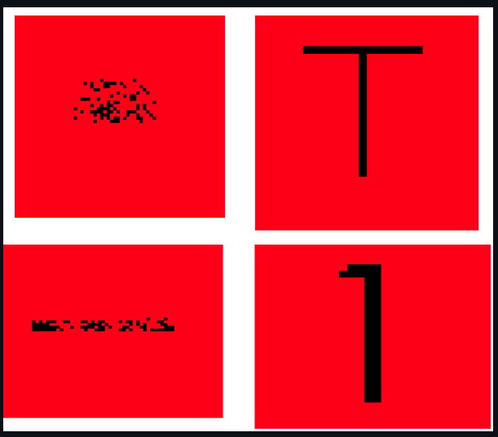

Fig 11:

Below is the representation for Overlap, Difference and Union:

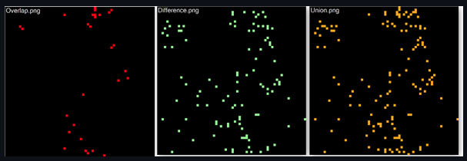

Fig 12:

On comparison between two SDRs, the overlap.png shows more overlaps/intersections in comparison to the above example. SDRs are similar to each other.

# Results

This Part of the text describes results of your works. There can only be mentioned references, MUST point back to Methods and Intro chapter. No more external references.

Code examples must be provided to demonstrate how to use the algorithm/module. Provide a reference to more unit tests, which show the same in more detail. Also provide all diagrams with comments and reference to unit tests, which generate diagrams.

# Discussion

Conclusion of your work should be precise and concise. How was the project, what is done, what is the result... There can be discussion on further work and direction.

# Ease of Use

## Selecting a Template (Heading 2)

First, confirm that you have the correct template for your paper size. This template has been tailored for output on the A4 paper size. If you are using US letter-sized paper, please close this file and download the Microsoft Word, Letter file.

## Maintaining the Integrity of the Specifications

The template is used to format your paper and style the text. All margins, column widths, line spaces, and text fonts are prescribed; please do not alter them. You may note peculiarities. For example, the head margin in this template measures proportionately more than is customary. This measurement and others are deliberate, using specifications that anticipate your paper as one part of the entire proceedings, and not as an independent document. Please do not revise any of the current designations.

# Prepare Your Paper Before Styling

Before you begin to format your paper, first write and save the content as a separate text file. Complete all content and organizational editing before formatting. Please note sections A-D below for more information on proofreading, spelling and grammar.

Keep your text and graphic files separate until after the text has been formatted and styled. Do not use hard tabs, and limit use of hard returns to only one return at the end of a paragraph. Do not add any kind of pagination anywhere in the paper. Do not number text heads-the template will do that for you.

## Abbreviations and Acronyms

Define abbreviations and acronyms the first time they are used in the text, even after they have been defined in the abstract. Abbreviations such as IEEE, SI, MKS, CGS, sc, dc, and rms do not have to be defined. Do not use abbreviations in the title or heads unless they are unavoidable.

## Units

* Use either SI (MKS) or CGS as primary units. (SI

units are encouraged.) English units may be used as secondary units (in parentheses). An exception would

* be the use of English units as identifiers in trade, such as “3.5-inch disk drive”.
* Avoid combining SI and CGS units, such as current in amperes and magnetic field in oersteds. This often leads to confusion because equations do not balance dimensionally. If you must use mixed units, clearly state the units for each quantity that you use in an equation.
* Do not mix complete spellings and abbreviations of units: “Wb/m2” or “webers per square meter”, not “webers/m2”. Spell out units when they appear in text: “. . . a few henries”, not “. . . a few H”.

may use the solidus ( / ), the exp function, or appropriate exponents. Italicize Roman symbols for quantities and variables, but not Greek symbols. Use a long dash rather than a hyphen for a minus sign. Punctuate equations with commas or periods when they are part of a sentence, as in:

*a*  *b*    

Note that the equation is centered using a center tab stop. Be sure that the symbols in your equation have been defined before or immediately following the equation. Use “(1)”, not “Eq. (1)” or “equation (1)”, except at the beginning of a sentence: “Equation (1) is . . .”

## Some Common Mistakes

* The word “data” is plural, not singular.
* The subscript for the permeability of vacuum **0, and other common scientific constants, is zero with subscript formatting, not a lowercase letter “o”.
* In American English, commas, semicolons, periods, question and exclamation marks are located within quotation marks only when a complete thought or name is cited, such as a title or full quotation. When quotation marks are used, instead of a bold or italic typeface, to highlight a word or phrase, punctuation should appear outside of the quotation marks. A parenthetical phrase or statement at the end of a sentence is punctuated outside of the closing parenthesis (like this). (A parenthetical sentence is punctuated within the parentheses.)
* A graph within a graph is an “inset”, not an “insert”. The word alternatively is preferred to the word “alternately” (unless you really mean something that alternates).
* Do not use the word “essentially” to mean “approximately” or “effectively”.
* In your paper title, if the words “that uses” can accurately replace the word “using”, capitalize the “u”; if not, keep using lower-cased.
* Be aware of the different meanings of the homophones “affect” and “effect”, “complement” and “compliment”, “discreet” and “discrete”, “principal” and “principle”.
* Do not confuse “imply” and “infer”.
* The prefix “non” is not a word; it should be joined to the word it modifies, usually without a hyphen.
* There is no period after the “et” in the Latin abbreviation “et al.”.
* The abbreviation “i.e.” means “that is”, and the abbreviation “e.g.” means “for example”.

An excellent style manual for science writers is [7].

# Using the Template

After the text edit has been completed, the paper is ready for the template. Duplicate the template file by using the Save As command, and use the naming convention prescribed by your conference for the name of your paper. In this newly created file, highlight all of the contents and import your prepared text file. You are now ready to style your paper; use the scroll down window on the left of the MS Word Formatting toolbar.

## Authors and Affiliations

**The template is designed for, but not limited to, three authors.** A minimum of one author is required for all report articles. Author names should be listed starting from left to right and then moving down to the next line. This is the author sequence that will be used in future citations and by indexing services. Names should not be listed in columns nor group by affiliation. Please keep your affiliations as succinct as possible (for example, do not differentiate among departments of the same organization).

### For papers with more than three authors: Add author names horizontally, moving to a third row if needed for more than 8 authors.

### For papers with less than three authors: To change the default, adjust the template as follows.

#### Selection: Highlight all author and affiliation lines.

#### Change number of columns: Select the Columns icon from the MS Word Standard toolbar and then select the correct number of columns from the selection palette.

#### Deletion: Delete the author and affiliation lines for the extra authors.

## Identify the Headings

Headings, or heads, are organizational devices that guide the reader through your paper. There are two types: component heads and text heads.

Component heads identify the different components of your paper and are not topically subordinate to each other. Examples include Acknowledgments and References and, for these, the correct style to use is “Heading 5”. Use “figure caption” for your Figure captions, and “table head” for your table title. Run-in heads, such as “Abstract”, will require you to apply a style (in this case, italic) in addition to the style provided by the drop down menu to differentiate the head from the text.

Text heads organize the topics on a relational, hierarchical basis. For example, the paper title is the primary text head because all subsequent material relates and elaborates on this one topic. If there are two or more sub-topics, the next level head (uppercase Roman numerals) should be used and, conversely, if there are not at least two sub-topics, then no subheads should be introduced. Styles named “Heading 1”, “Heading 2”, “Heading 3”, and “Heading 4” are prescribed.

## Figures and Tables

For adding object other than text (tables, equations, graphs, figures, code…), **there must be at least one cross reference** to it. Figure 1 is an example

#### Positioning Figures and Tables: Place figures and tables at the top and bottom of columns. Avoid placing them in the middle of columns. Large figures and tables may span across both columns. Figure captions should be below the figures; table heads should appear above the tables. Insert figures and tables after they are cited in the text. Use the abbreviation “Fig. 1”, even at the beginning of a sentence.

1. Table Type Styles

| Table Head | Table Column Head | | |
| --- | --- | --- | --- |
| Table column subhead | Subhead | Subhead |
| copy | More table copya |  |  |

1. Sample of a Table footnote. (*Table footnote*)

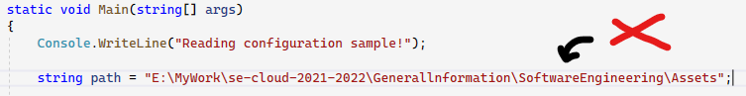

Figure 1 Example Figure Caption

Figure Labels: Use 8 point Times New Roman for Figure labels. Use words rather than symbols or abbreviations when writing Figure axis labels to avoid confusing the reader. As an example, write the quantity “Magnetization”, or “Magnetization, M”, not just “M”. If including units in the label, present them within parentheses. Do not label axes only with units. In the example, write “Magnetization (A/m)” or “Magnetization {A[m(1)]}”, not just “A/m”. Do not label axes with a ratio of quantities and units. For example, write “Temperature (K)”, not “Temperature/K”.

## Code References:

Referencing Code in your text should be avoided unless necessary. In such cases it can be inserted as a listing as shown in **Error! Reference source not found.**

Listing 1 Code Reference Example

Console.WriteLine(“Referencing code”, var);

// using tab can be replaced with 4 spaces

Do not pass code as image. When referring to variable in **Error! Reference source not found.**, italics should be used for example *var.* Code flows and logic should be presented better as Graph or Diagram instead of words.

Code Block which is too big to put in the textbox can be reference as Listing 2.

Listing 2 Unit Test [EncodeDateTimeTest](https://github.com/ddobric/neocortexapi/blob/0348ffb99739ddf8c8c3a875f8162a18073938ca/source/UnitTestsProject/EncoderTests/DateTimeEncoderExperimentalTests.cs#L34-L49)

public void EncodeDateTimeTest(int w, double r, …)

{

…

DateTimeEncoderExperimental encoder = new…

var result = encoder.Encode(input);

…

Assert.IsTrue(result.SequenceEqual(expected…

}

##### Acknowledgment *(Heading 5)*

The preferred spelling of the word “acknowledgment” in America is without an “e” after the “g”. Avoid the stilted expression “one of us (R. B. G.) thanks ...”. Instead, try “R. B. G. thanks...”. Put sponsor acknowledgments in the unnumbered footnote on the first page.

##### References

The template will number citations consecutively within brackets [1]. The sentence punctuation follows the bracket [2]. Refer simply to the reference number, as in [3]—do not use “Ref. [3]” or “reference [3]” except at the beginning of a sentence: “Reference [3] was the first ...”

Number footnotes separately in superscripts. Place the actual footnote at the bottom of the column in which it was cited. Do not put footnotes in the abstract or reference list. Use letters for table footnotes.

Unless there are six authors or more give all authors’ names; do not use “et al.”. Papers that have not been published, even if they have been submitted for publication, should be cited as “unpublished” [4]. Papers that have been accepted for publication should be cited as “in press” [5]. Capitalize only the first word in a paper title, except for proper nouns and element symbols.

For papers published in translation journals, please give the English citation first, followed by the original foreign-language citation [6].

1. G. Eason, B. Noble, and I. N. Sneddon, “On certain integrals of Lipschitz-Hankel type involving products of Bessel functions,” Phil. Trans. Roy. Soc. London, vol. A247, pp. 529–551, April 1955. *(references)*
2. J. Clerk Maxwell, A Treatise on Electricity and Magnetism, 3rd ed., vol. 2. Oxford: Clarendon, 1892, pp.68–73.
3. I. S. Jacobs and C. P. Bean, “Fine particles, thin films and exchange anisotropy,” in Magnetism, vol. III, G. T. Rado and H. Suhl, Eds. New York: Academic, 1963, pp. 271–350.
4. K. Elissa, “Title of paper if known,” unpublished.
5. R. Nicole, “Title of paper with only first word capitalized,” J. Name Stand. Abbrev., in press.
6. Y. Yorozu, M. Hirano, K. Oka, and Y. Tagawa, “Electron spectroscopy studies on magneto-optical media and plastic substrate interface,” IEEE Transl. J. Magn. Japan, vol. 2, pp. 740–741, August 1987 [Digests 9th Annual Conf. Magnetics Japan, p. 301, 1982].
7. M. Young, The Technical Writer’s Handbook. Mill Valley, CA: University Science, 1989.

**This report template contains guidance text for composing and formatting technical reports. Please ensure that all template text is removed from your report prior to submission to the examination office. Failure to remove template text from your paper may result in your paper being degraded.**

We suggest that you use a text box to insert a graphic (which is ideally a 300 dpi TIFF or EPS file, with all fonts embedded) because, in an MSW document, this method is somewhat more stable than directly inserting a picture.

To have non-visible rules on your frame, use the MSWord “Format” pull-down menu, select Text Box > Colors and Lines to choose No Fill and No Line.